Saturday, MAY 15, 2021
Virginia Conference United Methodist Women
Spiritual Life Retreat
Peace Be With You
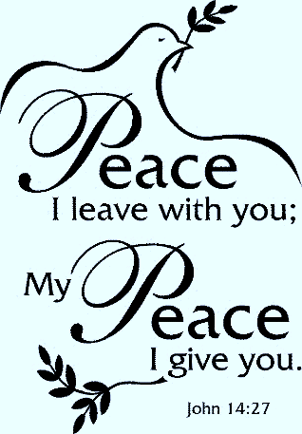

Our Speaker: Rev. Ileana Rosario
Pastor of Lower United Methodist Church

Time: 9:00 am – 1:00 pm
Agenda:
Greet One Another
Welcome and Zoom Tips
Opening Music and Prayer
Four Sessions followed by Break-out Groups:
Receiving Peace in My Heart
Sharing Peace within the United Methodist Church
Upholding Peace Despite Division
Spreading Peace Throughout the World
Closing Worship
Parting Words

Please register by May 3, 2021 by clicking on this link:

Spiritual Life Retreat registration

After registering, you will receive a confirmation email containing information about joining the meeting.

