Mission Central-Equipment for Caring Medical Closet opened in 2015 as a way to serve the local community. Research led us to believe we have both a need and a readily available supply of used durable medical equipment. The gently used pieces were collected from businesses and individuals in the community. We are now located in Mission Central at 1704 Smithland Rd, Harrisonburg, VA 22801. We continue to seek volunteers for manning the medical closet and for some pick-up and deliveries.

Needed items include:
Pediatric Equipment
Bariatric Equipment
Shower benches
Wheel chairs
Swivel seats
Bedside commodes
Tub grab bars
Hospital beds
Knee walkers
Rollator walkers with seat
Disposable briefs and/or adult diapers
Colostomy supplies
Assistive devices or disposables
Zipper pulls, buttoner
Long Handled shoe horn

We cannot accept or loan these items:
Medications
Walking boots or shoes
Equipment requiring a prescription or a medical specialist to supervise ie. CPAP/BiPAP machines

Frequently Asked Questions

Q. Who can use your medical equipment?
A. There is no age, disability, or residency restrictions to take a loan from our closet. No prescriptions are required.

Q. How does a person go about getting these items from you?
A. Items can be picked up at Mission Central 1704 Smithland Rd, Harrisonburg, VA Mondays 5-7 PM or Thursdays 9-11 AM. Please call Delores Reid 540-404-1159 or the Shenandoah River District UMC office 540-433-2382 if you have questions. Please do not leave items outside our doors “after hours”

Q. Why do I need to sign a contract?
A. A signed legal document informs the borrower that all our equipment may be a used item and releases us of liability for the loan of the equipment.

Q. How long can I keep the equipment?
A. We offer short-term loans and ask that you return if you no longer need it. This will give someone else to opportunity to use it.

Q. Is there a cost?
A. We offer these items to the community at no cost, and we welcome tax-deductible donations to assist with our costs.

Interested in Learning More?
We would be happy to come talk to your civic group, church, or organization to tell you more about our program. We want many people to benefit from this service. See back page for contact information.

Do you have medical equipment or related items in your closet, attic, or basement that is simply taking up space and is no longer needed?
Please consider giving it new use and life by donating it to the Equipment for Caring medical equipment loaner program. Our ongoing goal is to collect donated medical equipment to restock.

The community has a new resource:
A Medical Equipment Loaner Closet
Mission Central-
Equipment for Caring

Items in our inventory that may be available at the Harrisonburg Mission Central

Durable Medical Equipment
- Standard & Transport Wheelchairs
- Bedside Commodes
- Toilet Seat Risers
- Bath Benches / Shower Seats & stools
- A variety of walkers
- Canes and Crutches
- Nebulizers with tubing
- Hospital beds
- Rolling shower chair
- Hoyer lift

Assistive Devices
  - Grabbers, Sock Assist, leg lifters
  - Chair cushions
  - Slings
  - Walker attachments
  - Cloth incontinent pads
  - Divided plates

Free Disposable Accessories
  - Adult Briefs & pads
  - O2 and nebulizer tubing
  - Gauze, bandages
  - Isolations gowns, masks
  - Colostomy & catheter bags

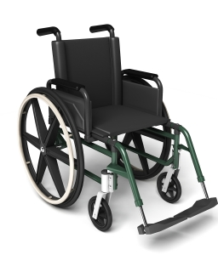
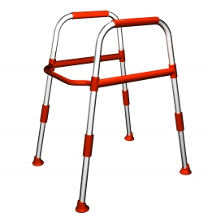

Vision Statement
Mission Central-
Equipment for Caring is a Christian organization that lends medical goods free of charge to those in the community who need them”

Location:
Mission Central
1704 Smithland Rd
Harrisonburg, VA
(Behind Cedar Grove UMC)

Correspondence/Mailing Address/Monetary Donations:
Equipment for Caring
P O Box 2026
Harrisonburg, VA 22801

Phone:
540-404-1159

Website:
www.missioncentralharrisonburgva.com
or
www.ShenandoahRiverdistrict.org/ ministries

       
Hours Open:
Monday 5-7 PM
Thursday 9-11 AM

Mission Central-Equipment for Caring is funded by generous donors, foundations, and fundraising events. We are a Christian, community-based, volunteer organization supported by various churches, organizations, and individuals. We welcome your tax-deductible contributions of time, money, and durable medical equipment.

